**Roles And Responsibilities(Phytora)**

**Front End Team**

@Paul Morales- Sr frontend developer

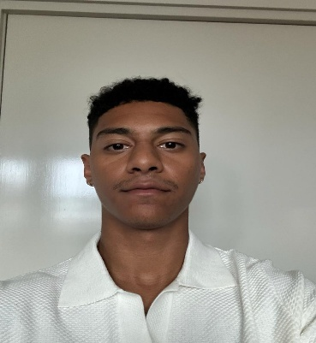

@Lakshmi- Jr Front end Developer

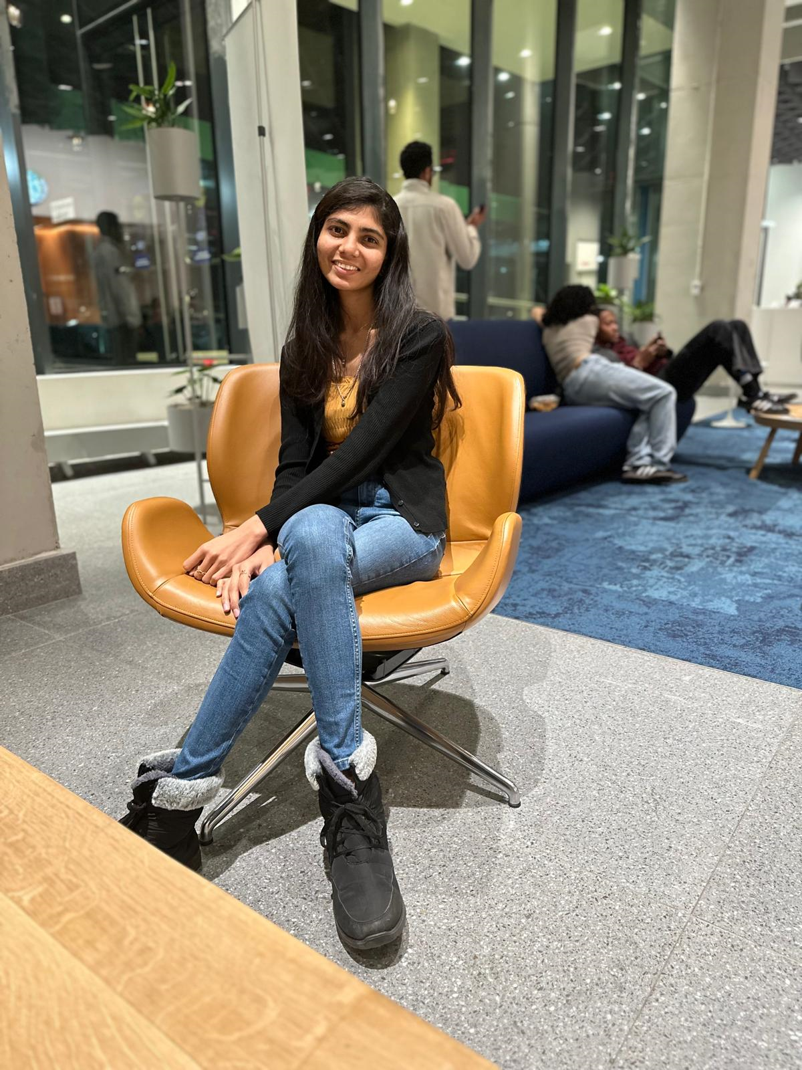

@Nikitha-Front end QA

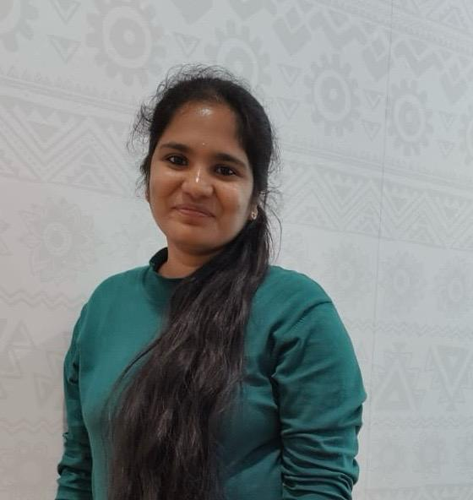

@Saipriya-Team Lead Front End



**Backend Team**

@Krishna Kishore -Sr. Back End Developer & Lead



@Gopi Krishna -Jr. Back End Developer



@Karthik- Back End QA

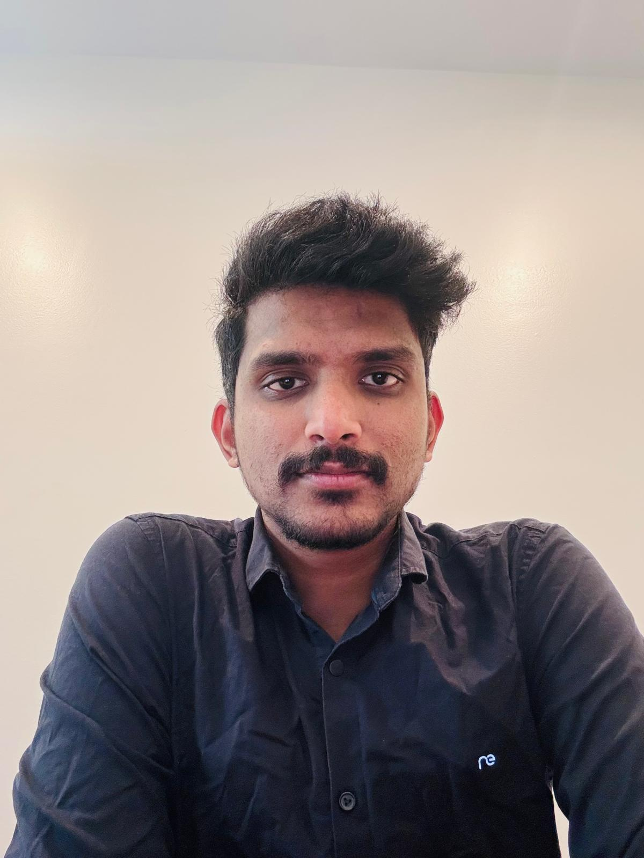

@Manoj Reddy-Scrum Master



Everyone need to update their work to lead every day

Team Lead Need to Update Their Work in EOD Report

Scrum Call 9:30 - 10:00 pm Clock Every Day